IFT 266 Introduction to Network Information Communication Technology (ICT)
Lab 2: Physical Layer Concepts

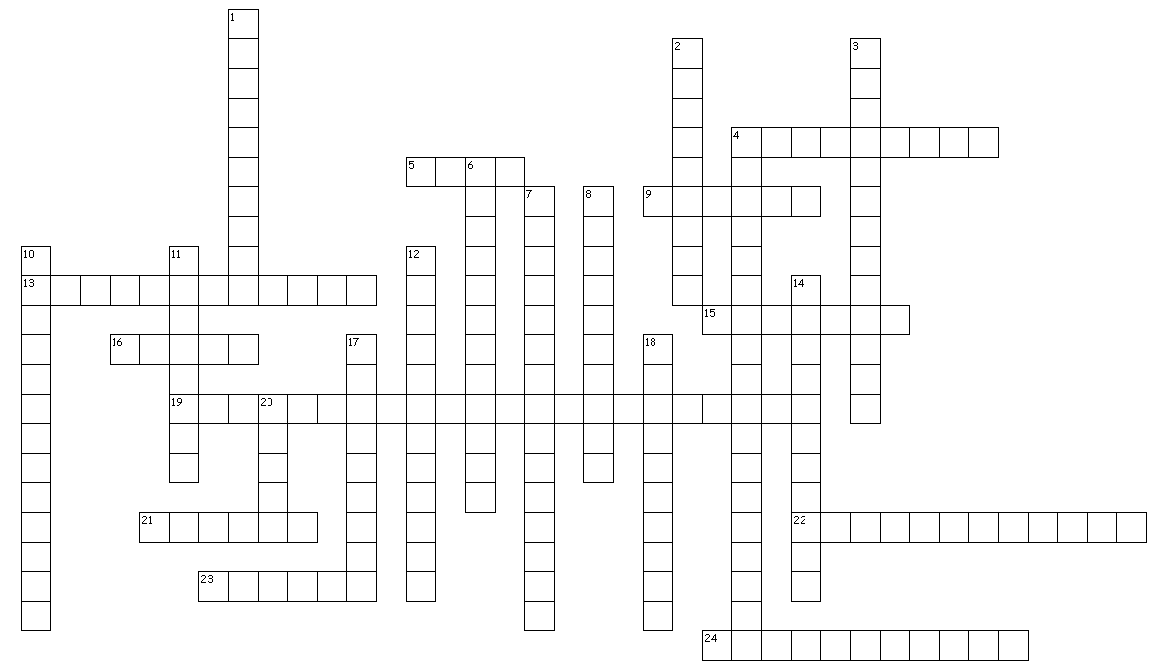

DO NOT RETURN THIS PAGE TO THE INSTRUCTOR WHEN YOU SUBMIT YOUR COMPLETED LAB
